**CSCI 1100 – Summer 2015**

**Laboratory Report 4**

**Name: Liam Gowan**

**Student ID:** B00673126

|  |  |  |
| --- | --- | --- |
| **Declaration: Please complete this declaration** | | |
| 1 | This document is entirely my own work. | Yes/no |
| 2 | I obtained help to complete this document (e.g., textbook, internet, friend, TA, instructor). | Yes/no. If ‘yes’ give Details.  Needed for converting CAD to USD  http://www.xe.com/currencyconverter/convert/?Amount=1&From=CAD&To=USD |
| 3 | This document contains some material copied or cut and pasted from the internet or another document or file or program. | Yes/no. If ‘yes’ give Details. |

*Your task is to complete this report using Word and JGrasp and to submit the complete word document on Moodle. Try to submit this report during the lab because then the TA can check it*

**Exercise 1.**

**Program:**

import javax.swing.JOptionPane; //imports JOptionPane method  
  
public class Lab4Temp{  
 public static void main(String[] args){  
 double celsius, fahrenheit; //declares double variables  
 //Prompts user for temperature, assigns it to tempInput  
 String tempInput = JOptionPane.showInputDialog("Please type the " +   
 "temperature in Fahrenheit:");  
 fahrenheit = Double.parseDouble(tempInput); //converts string to double  
 celsius = (fahrenheit - 32) / 1.8; //converts F to C  
   
 //Displays a pop up window showing conversion  
 JOptionPane.showMessageDialog(null, fahrenheit + " in Fahrenheit " +  
 "is " + celsius + " degrees in Celsius");  
 }  
}

**Output (Test the program with two sets of data ):**

**Test 1.**

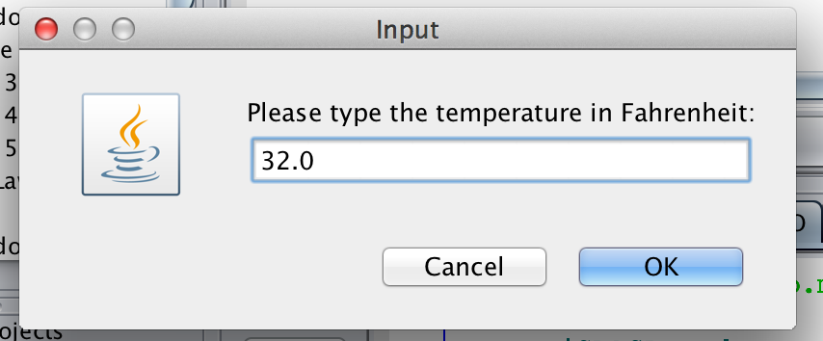

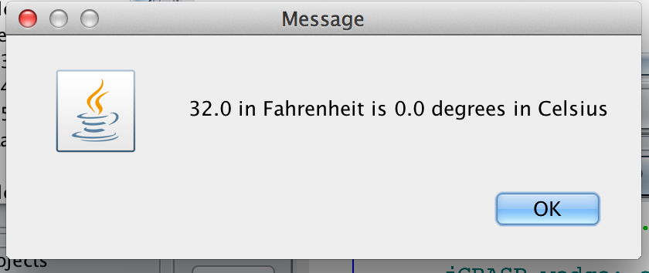

**Test 2.**

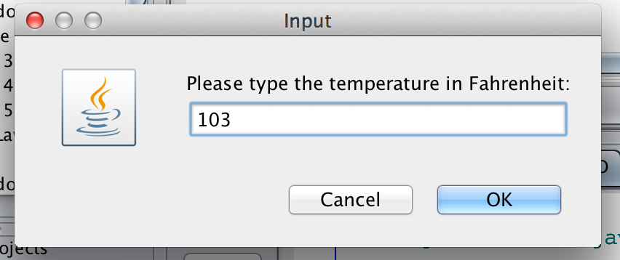

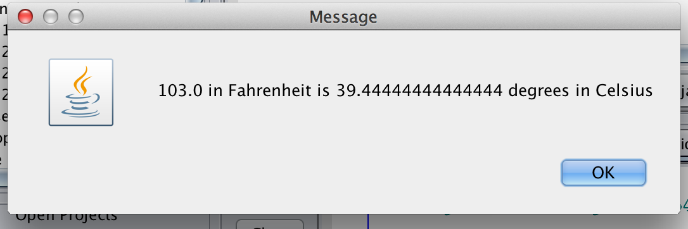

**Exercise 2.**

**Program:**

import javax.swing.JOptionPane; //imports JOptionPane method  
  
public class AnotherCurrencyConverter{  
 public static void main(String[] args){  
 double cost, tax, salesTax, cadTotal, usdTotal; //declares double variables  
 //prompts user for cost, converts string to double, assigns to cost  
 cost = Double.parseDouble(JOptionPane.showInputDialog("Please type the " +  
 "cost of the item:"));  
 //prompts user for tax, converts string to double, assigns to tax  
 tax = Double.parseDouble(JOptionPane.showInputDialog("Please type the " +  
 "GST percantage rate:"))/100;  
   
 salesTax = cost * tax; //calculates tax  
   
 cadTotal = cost + salesTax; //calculates total  
   
 usdTotal = cadTotal * 0.814; //converts total to USD  
   
 //displays cost, tax, total, and total in USD  
 JOptionPane.showMessageDialog(null, "Cost Cdn: $" + cost + " Plus Tax: $" + salesTax +  
 "\nTotal: $" + cadTotal + " Cdn or in US$: " + usdTotal);  
 }  
}

**Output (Test the program with two sets of data ):**

**Test 1.**

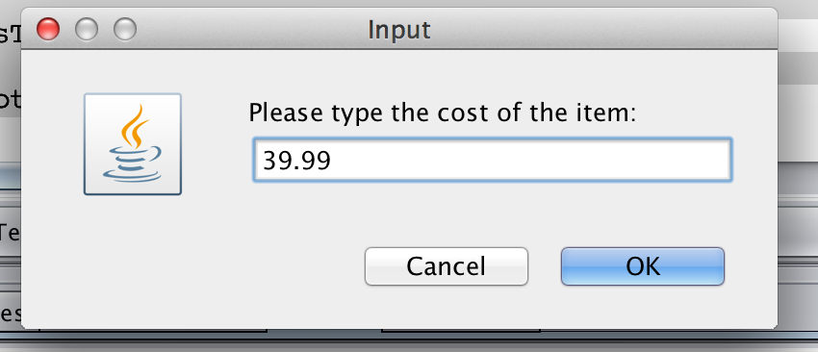

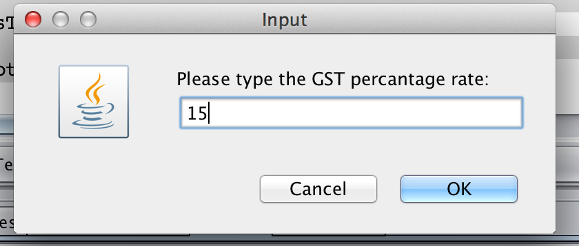

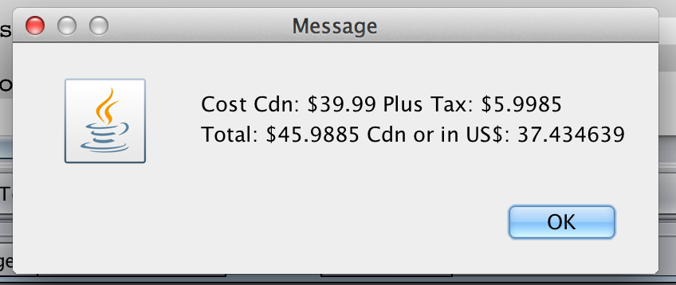

**Test 2.**

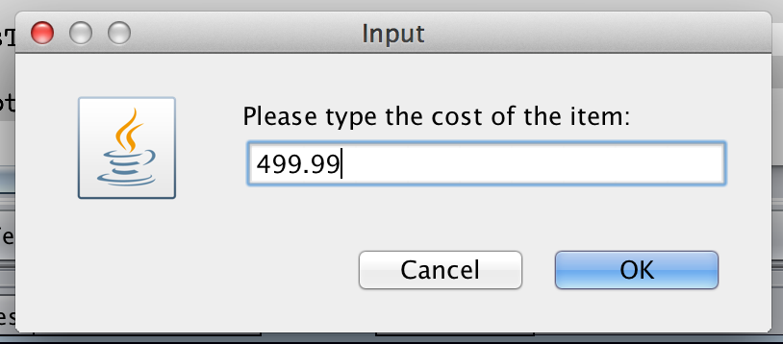

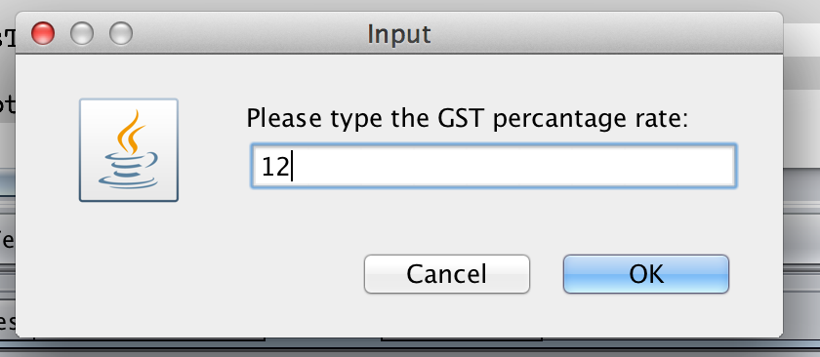

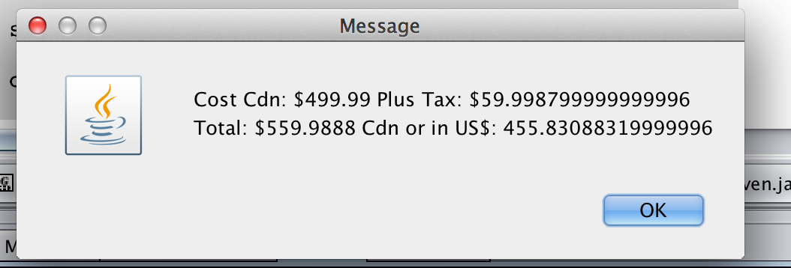

**Exercise 3**.

**Program:**

import java.util.Scanner;//imports scanner class  
  
public class BoxRectangleArea{  
 public static void main(String[] args){  
 double height, length, area; //declares double variables  
 Scanner input = new Scanner(System.in); //declares scanner variable  
 String shape = "square"; //declares string variable  
   
 //prompts user for box height, assigns to 'height'  
 System.out.print("Enter the height of the box: ");  
 height = input.nextDouble();  
   
 //prompts user for box length, assigns to 'length'  
 System.out.print("Enter the length of the box: ");  
 length = input.nextDouble();  
   
 area = height * length; //calculates area  
   
 if(height == length) //make shape a square if height = length  
 shape = "square";  
 else  
 shape = "rectangle"; //make shape a rectangle if height = length  
   
 //print box height, length, shape and area  
 System.out.print("The box of " + height + " x " + length + " is a "  
 + shape + " and has the area of " + area);  
 }  
}

**Output (Test the program with two sets of data – show both cases ):**

**Test 1.**

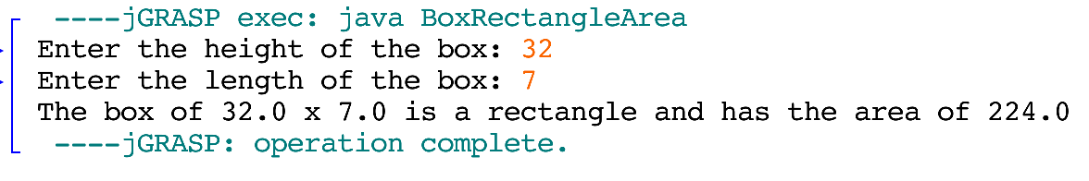

**Test 2.**

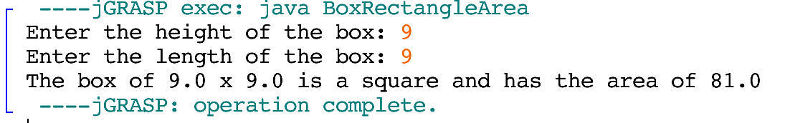

**Exercise 4.**

**Program:**

import java.util.Scanner; //import scanner class  
  
public class ClassMark{  
 public static void main(String[] args){  
 double first, second, average; //declare double variables  
 Scanner input = new Scanner(System.in); //declares scanner variable  
   
 //prompts user for first mark, assigns to first  
 System.out.print("Please type the first mark out of 15: ");  
 first = input.nextDouble() / 15;  
   
 //prompts user for second mark, assigns to second   
 System.out.print("Please type the second mark out of 45: ");  
 second = input.nextDouble() / 45;  
   
 average = ((first + second) / 2) * 100; //calculates average  
   
 System.out.println("Your average is: " + average + "%"); //displays average  
   
 if(average > 80) //if average is greater than 80, it says you're doing well  
 System.out.print("You are doing fine.");  
 else{ //other wise it'll tell you to get help  
 System.out.print("You should go to the learning centre to get "  
 + "some extra help.");  
 }  
 }  
}

**Output (Test the program with two sets of data – show both cases):**

**Test 1.**

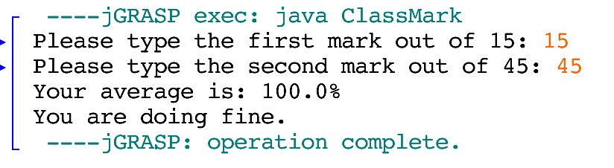

**Test 2.**

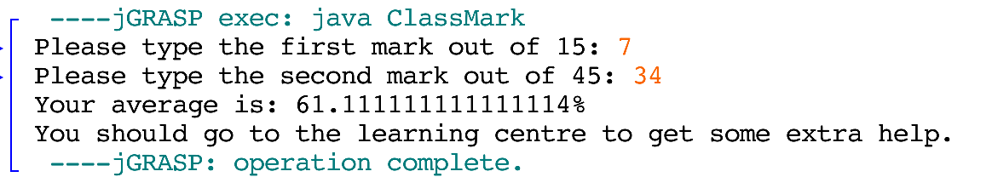

**Exercise 5.**

**Program:**

import java.util.Random; //imports random class  
import java.util.Scanner; //imports scanner class  
  
public class RandomGen{  
 public static void main(String[] args){  
 Random randomNumber = new Random(); //declares random variable  
 int number = randomNumber.nextInt(10) + 1; //makes number between 1-10, assigns to int  
 int guess; // declares to int variable  
 Scanner input = new Scanner(System.in); //declares scanner variable  
   
 //prompts user for number, assigns it to guess  
 System.out.print("I have a number between 1 and 10. " +  
 "Please enter your guess: ");  
 guess = input.nextInt();  
   
 if(guess != number){ //if guess is incorrect, tell user the number and good luck  
 System.out.print("Wrong - It was " + number +   
 ". Better luck next time.");  
 }  
 else //if guess is correct, tell user good guess  
 System.out.print("Good guess");  
 }  
}

**Output (Test the program with two sets of data ):**

**Test 1.**

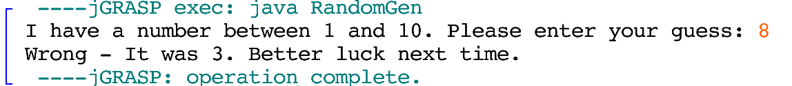

**Test 2.**



**Exercise 6.**

**Program:**

import java.util.Scanner;//imports scanner class  
  
public class WhatShouldIWear{  
 public static void main(String[] args){  
 double temp; //declares double variable  
 Scanner input = new Scanner(System.in); //declares scanner variable  
   
 //prompts user for temp, assigns to temp  
 System.out.print("Enter the temperature: ");  
 temp = input.nextDouble();  
   
 /*The following nested if statements test to see if the  
 temperature is greater than 30, greater than 25 but less than  
 30, greater than 20 but less than 25, greater than 15 but   
 less than 20, greater than 10 but less than 15, or between 0 and 10.  
 It will then print what you should wear.  
 */  
 if(temp >= 30){  
 System.out.print("It is really hot - stay indoors");  
 }  
 else{  
 if (temp >= 25 && temp < 30){  
 System.out.print("Wear sunscreen and a hat");  
 }  
 else{  
 if (temp >= 20 && temp < 25){  
 System.out.print("You won't need a sweater today");  
 }  
 else{  
 if (temp >= 15 && temp < 20){  
 System.out.print("You will need a sweater today");  
 }  
 else{  
 if (temp >= 10 && temp < 15){  
 System.out.print("You should take a jacket");  
 }  
 else{  
 if(temp > 0 && temp < 10){  
 System.out.print("Wear a hat and mittens");  
 }   
 }  
 }  
 }  
 }  
 }  
 }  
}

**Output (Test the program with ALL possible outcomes ):**

**All 6 Tests:**

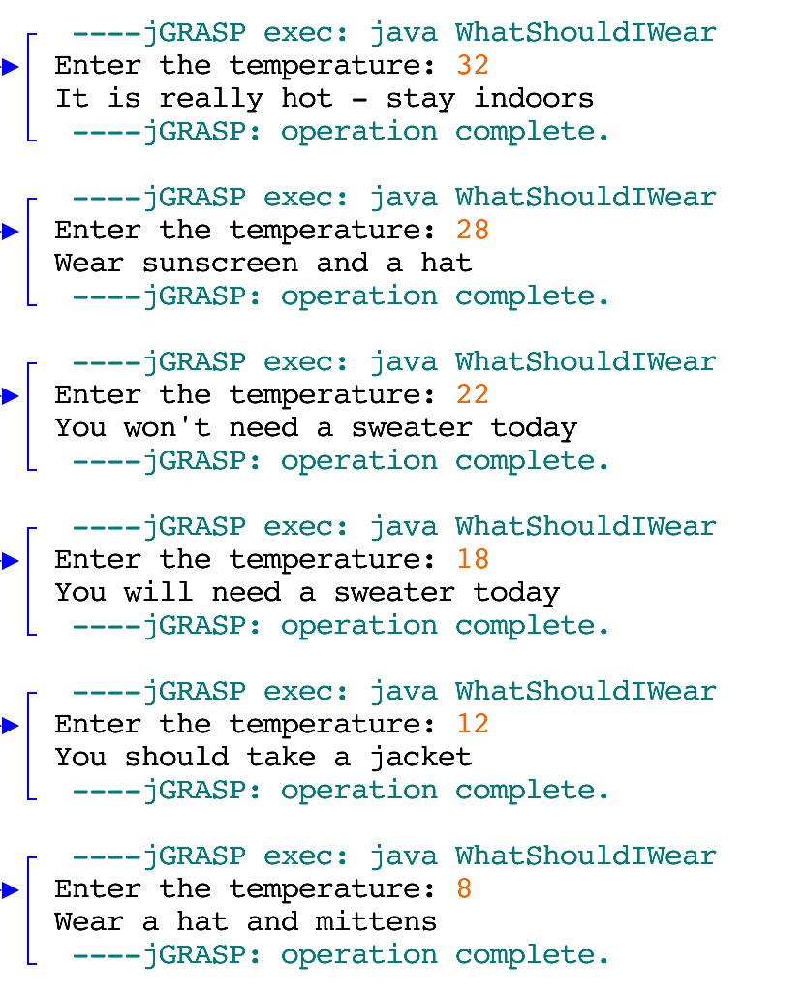

**Please note.** Complete all the exercises in this report. Remove all unnecessary information from this report including this note and questions that are not required. Keep only exercises and solutions. Ask the TA to check this report for you.

Checklist for report submission:

1. Write your name, id and mark the lab session you are in.
2. Have you commented each program?
3. Have you formatted each program neatly? (Ask a TA.)
4. Is the report overall up to standard? (Ask a TA.)
5. Have you tested the programs with required set of data and included the results in this report.

Don’t forget to log off.